RURAL OFFICE TO LET
The Harness Room
Whitehouse Farm Business Centre
Gaddesden Row
Hemel Hempstead
Herts
HP2 6HG

£571 plus VAT per calendar month
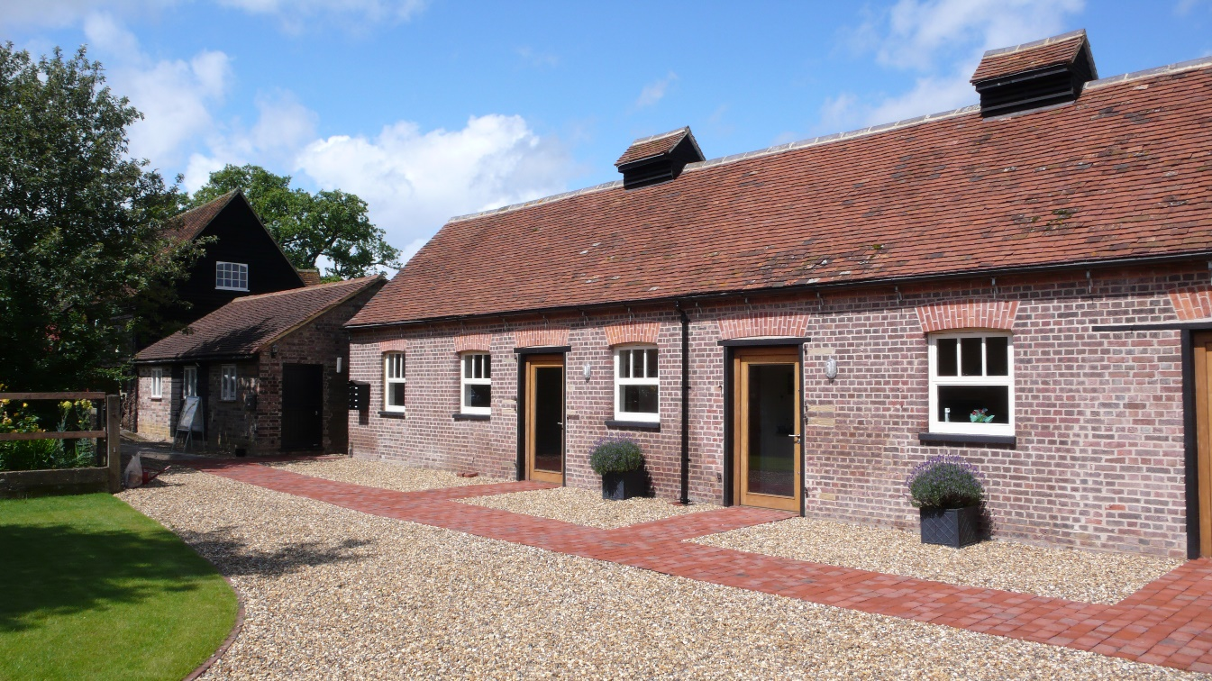
- Office accommodation in attractive rural location
- Approximately 474 sq ft (44 sq m)
- Ample on-site parking
- Easy access to M1 and M25 and rail network to London Euston and St Pancras
- High speed broadband available

LOCATION
The Harness Room is located on the Whitehouse Farm Business Centre set in the rural location of Gaddesden Row, Hertfordshire. Gaddesden Row is approximately 4 miles from Junction 9 of the M1.
St Albans, the M25 and M40 are also within a few miles, as are the railway stations at Hemel Hempstead, Berkhamsted and St Albans, which all offer fast commuter services to London.
DESCRIPTION
The property comprises of a large and open room with vaulted ceiling, with a kitchenette, stainless steel sink, worktop with fridge underneath. There is a second smaller room off of this room, ideal for a single office or meeting room.
The toilets are maintained by the landlord and are shared with the adjoining unit.
Oil fired underfloor central heating.
TERMS AND CONDITIONS
Rent: £571 plus VAT per calendar month
Rates: Rates are payable. All enquiries to Dacorum Borough Council.
Costs: Each party will be responsible for their own legal and
surveyors’ costs.

Service Charge: A service charge of £1.50 + VAT per sq ft is payable.

Lease: Terms to be agreed for new leases, rent and length of term negotiable.

Deposit: A deposit equal to the amount of three month’s rent will be required.

Start Date: TBA

Charges: Referencing:
£50 plus VAT per individual applicant
£50 plus VAT per guarantor
£50 plus VAT per company

Inventory
The cost of the ingoing inventory will be recharged to the tenant at a cost of £130 plus VAT.

DIRECTIONS

Take the A416 from Hemel Hempstead towards Leighton Buzzard. Proceed to Water End, turning right opposite the Red Lion Public House in Red Lion Lane. Go through the hamlet of Bridens Camp to the T junction. Turn left and Whitehouse Farm Business Centre is approximately ½ mile on the right-hand side opposite the water tower.

VIEWING

To arrange a viewing or discuss the property, please contact the Gaddesden Estate Office on 01442 252421 or estateoffice@gaddesdenestate.co.uk.

Important Notice

Gaddesden Estate give notice that:

- The particulars are intended to give a fair and substantially correct overall description for the guidance of intending tenants and do not constitute part of an offer or contract. Prospective tenants ought to seek their own professional advice.
- All descriptions dimensions, areas, reference to condition and necessary permissions for use and occupation and other details are given in good faith, and are believed to be correct, but any intending tenants should not rely on them as statements or representations of fact, but must satisfy themselves by inspections or otherwise as to the correctness of each of them.
- No responsibility can be accepted for any expenses incurred by intending tenants in inspecting properties which have been sold, let or withdrawn. Photograph taken September 2011. Particulars prepared December 2017.
- Measurements and other information All measurements are approximate. While we endeavour to make our particulars accurate and reliable, if there is any point which is of particular importance to you, please contact this office and we will be pleased to check the information for you, particularly if contemplating travelling some distance to view the property.

EPC to be added

